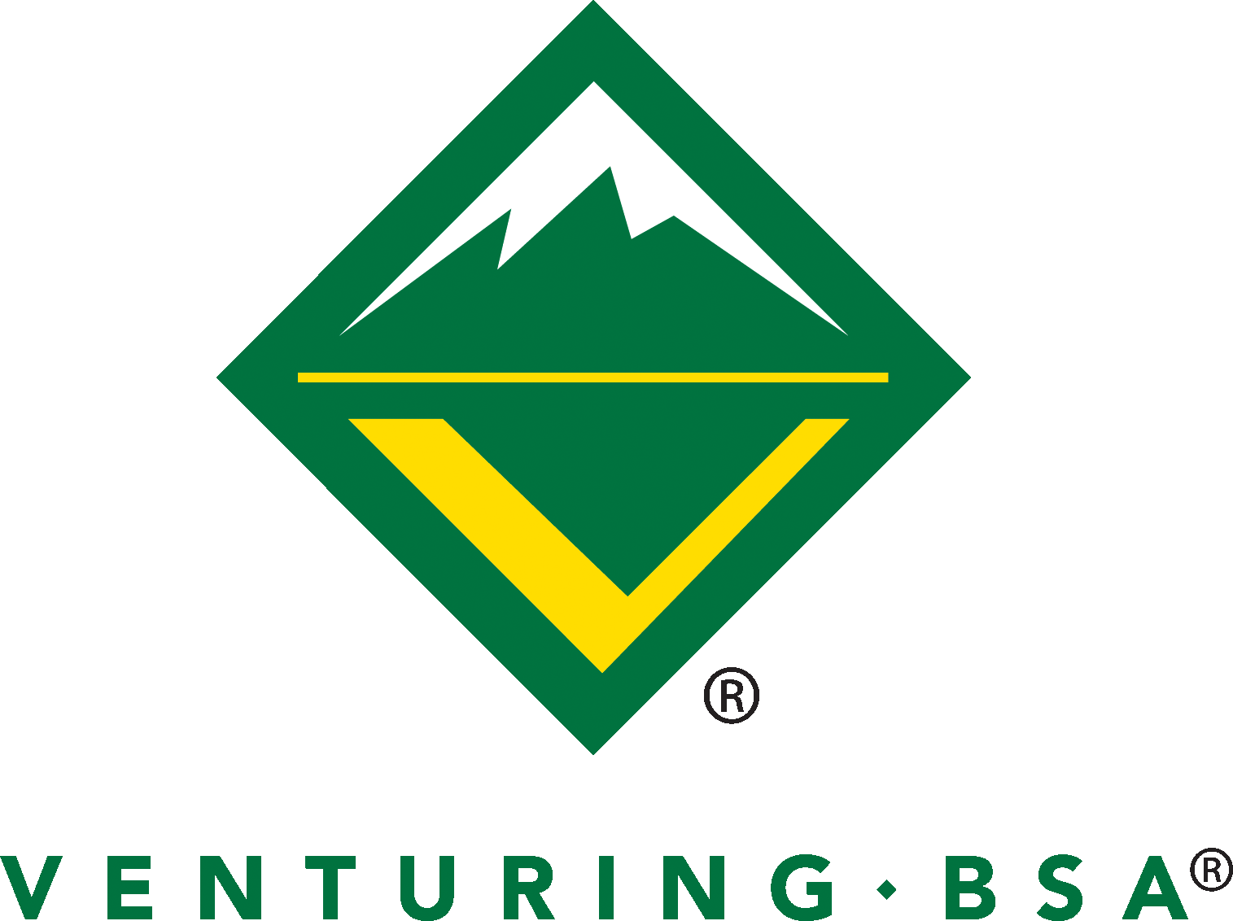
Venture Crew 2526

Spring Meetings -

Advisor Conference Form

Directions: Below are the questions that you will be asked in the Advisor conference. If at all possible, complete this form in advance, and either bring 2 copies OR we will make a copy before the meeting.

Name: Click here to enter text.
What is your current Venture Rank? Click here to enter text.
What Venture goals do you want to complete the rest of this year?
(goals can be advance to the next rank, participate in a specific adventure, learn something, develop a new leadership skill, help the community, help the crew, etc. but please be as specific as possible)
Click here to enter text.
Are you interested in a leadership position in the crew next year? Yes ☐ No ☐
What officer position(s) are you interested in? Click here to enter text.
Advancement requires taking leadership in a crew Tier 2 or Tier 3 activity. What activities have you done, or will you do this year? Click here to enter text.
Any other things you want to discuss in the Advisor conference?
Click here to enter text.

